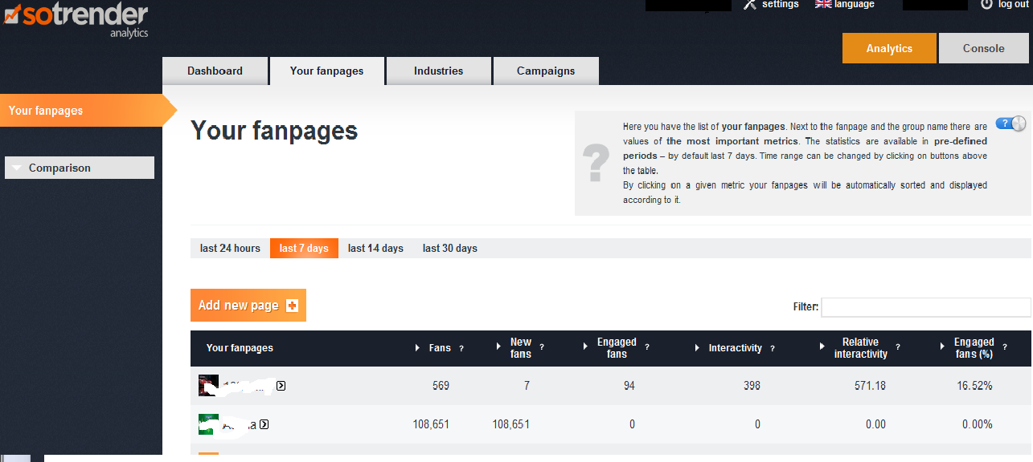
Select a Facebook page from the list by clicking on it
Go to Your fanpages tab
How to select a Facebook page for TIPS analysis?

